**Name- Vedant Roy**

**Email ID-** [**vedantroy3@gmail.com**](mailto:vedantroy3@gmail.com)

**IBM SkillsBuild Micro Internship Data Science Assignment- 1**

id weight bp locality smoking tumour

1 20 140 urban no small

2 27 130 rural yes small

3 24 120 urban no large

4 22 134 urban yes small

5 23 100 rural yes large

6 25 116 rural no small

7 28 143 urban yes large

**Assignment 1:**

**1) Please write the command to create data frame in R.**

**Ans**

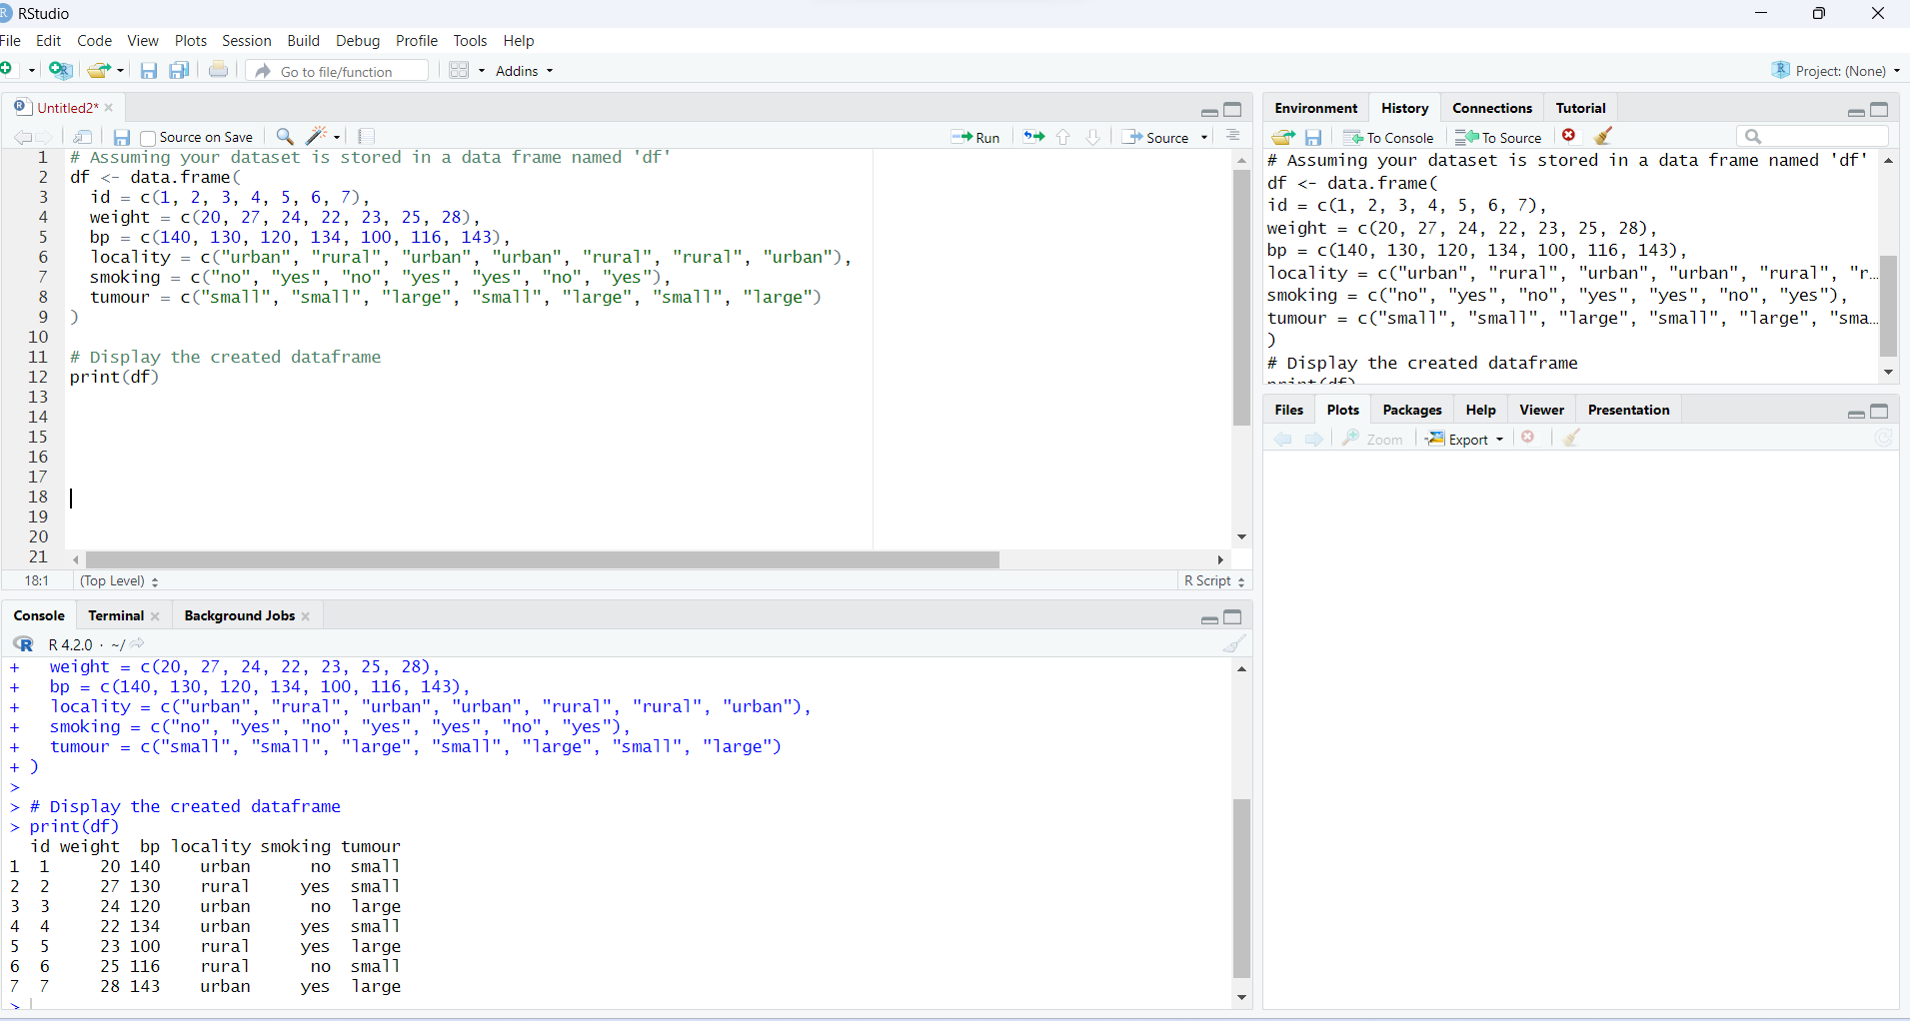

**Q2) Please write the command for plotting the graph between weight and bloodpressure.**

**Ans**

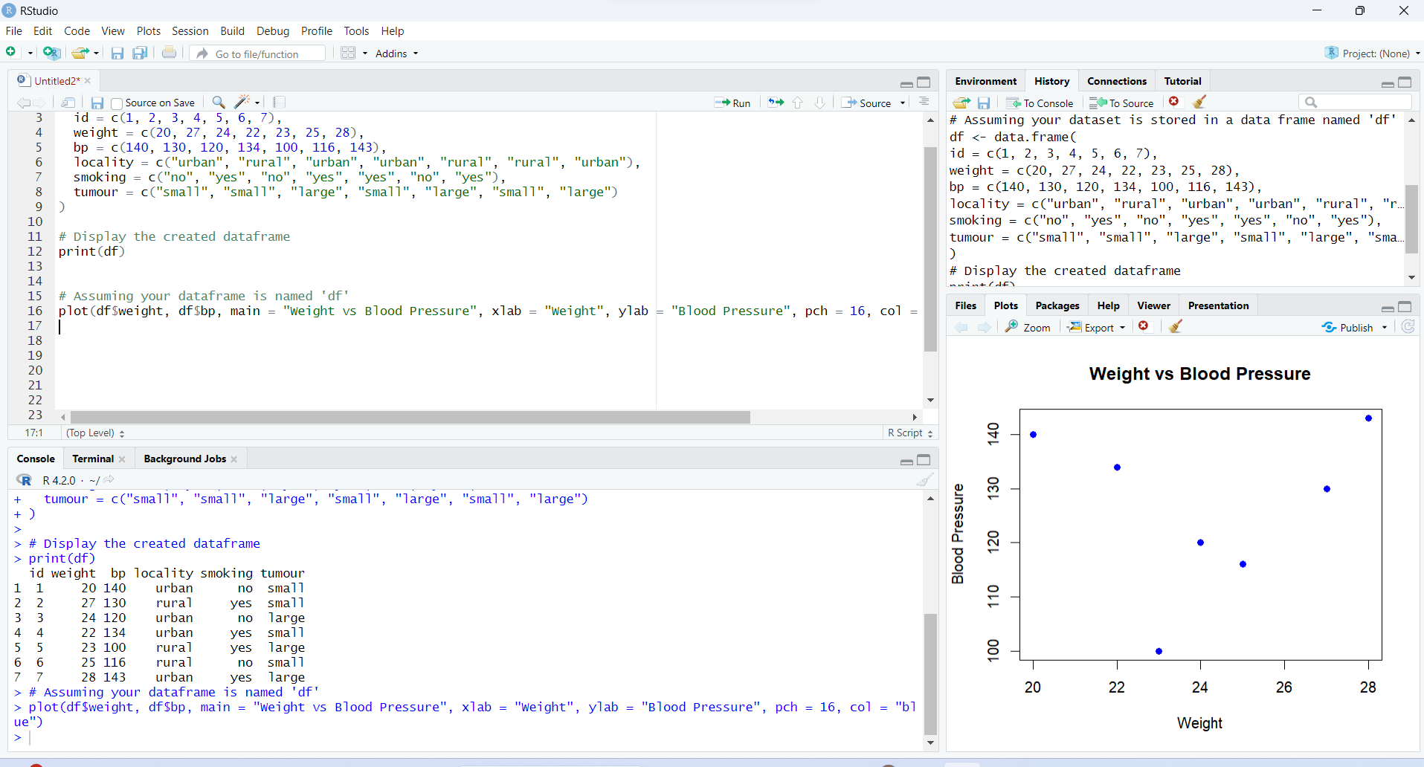

**Q3) Please write the command for creating stacked chart between smoking and tumour.**

**Ans**

